AKC Event 2025289311


AKC Pointing Breed Hunting Test

Held by the
German Shorthaired Pointer Club of Ohio
PINK TEST
Licensed by the American Kennel Club®

Saturday Morning, October 4, 2025

Swamp Collie Acers
382 Curllsville Road, Rimersburg, PA

This Hunt Test is held under the rules and regulations of the American Kennel Club®.

JUDGES AND STAKES TO BE JUDGED

Master and Senior Hunt Tests.
Dan Kaminski & Eileen Murdock

Junior Hunt Test
Gary Nagy & Roberta Morgan

OFFICERS OF THE CLUB
Dennis Meinke, 120 Oakland Rd Mercer Pa., 16137 ….…………......... President
Chuck Meadors, 3880 Arrel Rd, Poland, OH 44514 ……..………...Vice President
Gary Nagy 14651 Creed Rd. Diamond, OH …………………………….Treasurer
Sherry Meinke, 120 Oakland Rd. Mercer Pa., 16137……………………Secretary
Hunt Test Committee

Chair: Dennis Meinke 120 Oakland Road, Mercer, Pa 16137
Secretary: Sherry Meinke 120 Oakland Road, Mercer Pa 16137
shermeinke@zoominternet.net 724-662-5682 Cell 724-992-2442
Members: Chuck & Peggy Meadors,, Donna & Joe McMullen,
Mike Murdock
Club Web Site: http://gspcofohio.org

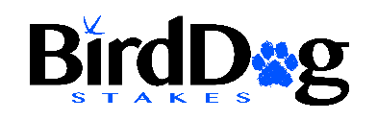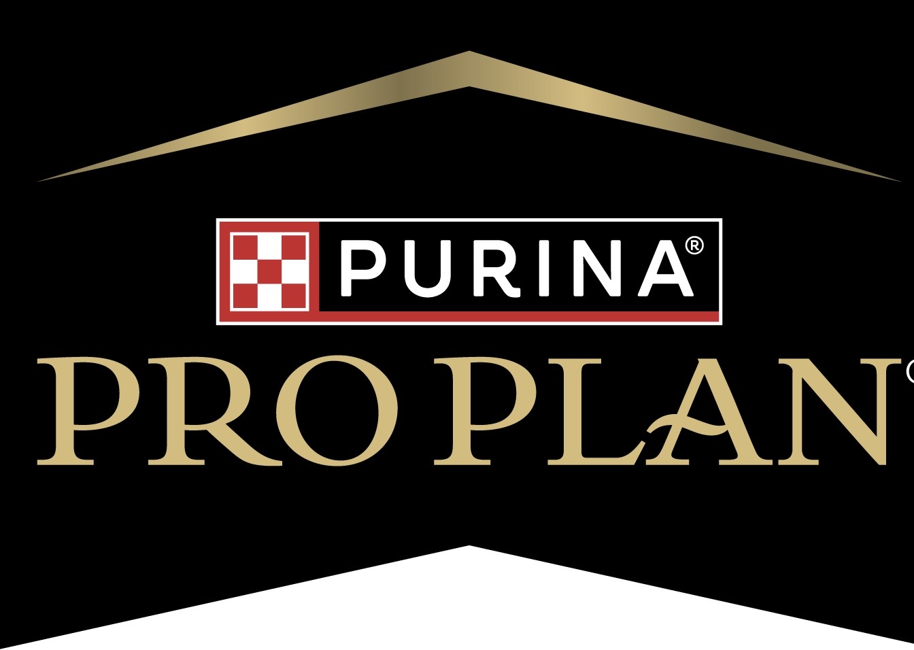

AKC Event 2025289312
AKC Pointing Breed Hunting Test

Held by the
German Shorthaired Pointer Club of Ohio
BLUE TEST
Licensed by the American Kennel Club®

Saturday Afternoon, October 4, 2025

Swamp Collie Acers
382 Curllsville Road, Rimersburg, PA

This Hunt Test is held under the rules and regulations of the American Kennel Club®.

JUDGES AND STAKES TO BE JUDGED

Master and Senior Hunt Tests.
Linda Pruitt & Jeff White

Junior Hunt Test
Gary Nagy & Don Cummings

OFFICERS OF THE CLUB
Dennis Meinke, 120 Oakland Rd Mercer Pa., 16137 … …………......... President
Chuck Meadors, 3880 Arrel Rd, Poland, OH 44514 ……..………...Vice President
Gary Nagy 14651 Creed Rd. Diamond, OH …………………………….Treasurer
Sherry Meinke, 120 Oakland Rd. Mercer Pa., 16137……………………Secretary

HUNTING TEST COMMITTEE

Chairman Dennis Meinke 120 Oakland Road, Mercer, Pa 16137
Secretary: Sherry Meinke 120 Oakland Road, Mercer Pa 16137
shermeinke@zoominternet.net 724-662-5682 Cell 724-992-2442
Members: Chuck & Peggy Meadors, Donna & Joe McMullen,
Mike Murdock

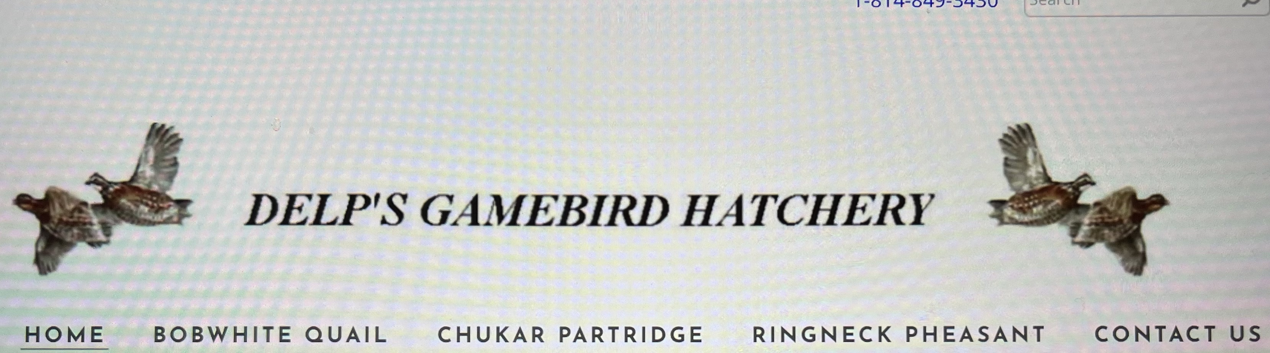

‘Hunting Test Premium List AKC Event 2025289313

AKC Pointing Breed Hunting Test

Held by the
German Shorthaired Pointer Club of Ohio
GREEN TEST
Licensed by the American Kennel Club®

Sunday Morning, October 5, 2025

Swamp Collie Acers
282 Curllsville Road, Rimersburg, PA

This Hunt Test is held under the rules and regulations of the American Kennel Club®.

JUDGES AND STAKES TO BE JUDGED

Master and Senior Hunt Tests.
Roberta Morgan & Lindam Pruitt

Junior Hunt Test
Dan Kaminski & Douglas Weber Jr

OFFICERS OF THE CLUB
Dennis Meinke, 120 Oakland Rd Mercer Pa., 16137 … …………......... President
Chuck Meadors, 3880 Arrel Rd, Poland, OH 44514 ……..………...Vice President
Gary Nagy 14651 Creed Rd. Diamond, OH …………………………….Treasurer
Sherry Meinke, 120 Oakland Rd. Mercer Pa., 16137……………………Secretary

HUNTING TEST COMMITTEE

Chairman Dennis Meinke 120 Oakland Road, Mercer, Pa 16137
Secretary: Sherry Meinke 120 Oakland Road, Mercer Pa 16137
shermeinke@zoominternet.net 724-662-5682 Cell 724-992-2442
Members: Chuck & Peggy Meadors, Donna & Joe McMullen,
Mike Murdock

Club Web Site: http://gspcofohio.org

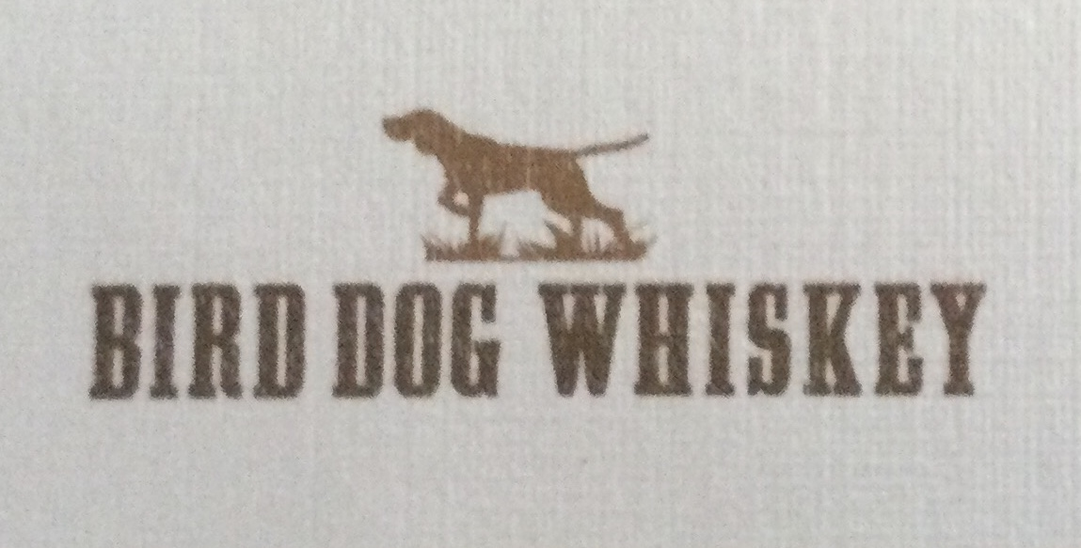

Hunting Test Premium List AKC Event 2025289314

AKC Pointing Breed Hunting Test

Held by the
German Shorthaired Pointer Club of Ohio
ORANGE TEST
Licensed by the American Kennel Club®

Sunday Afternoon, October 5, 2025

Swamp Collie Acers
382 Curllsville Road, Rimersburg, PA

This Hunt Test is held under the rules and regulations of the American Kennel Club®.

JUDGES AND STAKES TO BE JUDGED

Master and Senior Hunt Tests.
Don Cummings & Gary Nagy

Junior Hunt Test
Eileen Murdock & Jeff White

OFFICERS OF THE CLUB
Dennis Meinke, 120 Oakland Rd Mercer Pa., 16137 … …………......... President
Chuck Meadors, 3880 Arrel Rd, Poland, OH 44514 …….………...Vice President
Gary Nagy 14651 Creed Rd. Diamond, OH ……………………………. Treasurer
Sherry Meinke, 120 Oakland Rd. Mercer Pa., 16137……………………Secretary
HUNTING TEST COMMITTEE

Chairman: Dennis Meinke 120 Oakland Road, Mercer, Pa 16137 Secretary: Sherry Meinke 120 Oakland Road, Mercer Pa., 16137
shermeinke@zoominternet.net 724-662-5682 Cell 724-992-2442
Members: Chuck & Peggy Meadors, Donna & Joe McMullen,
Mike Murdock
Club Web Site: http://gspcofohio.org



PINK and BLUE TESTS
SATURDAY SCHEDULE AND ENTRY FEES
MORNING
PINK Test Level Start Time Entry Fee
Junior Hunt Test 7:30 AM local time $60.00
Master Hunt Test 7:30 AM $60.00
Senior Hunt Test to follow Master $60.00

AFTERNOOM
BLUE Test Level Start Time Entry Fee
Master Hunt Test After PINK Seniors $60.00
Senior Hunt Test to follow Master $60.00
Junior Hunt Test to follow PINK Juniors Test $60.00

SUNDAY SCHEDULE AND ENTRY FEES
MORNING
Green Test Level Start Time Entry Fee
Master Hunt Test 7:30 AM local time $60.00
Senior Hunt Test to follow Master $60.00
Junior Hunt Test 7:30 AM $60.00

AFTERNOON
Orange Test Level Entry Fee
Junior Hunt Test After GREEN Juniors $60.00
Master Hunt Test After GREEN Seniors $60.00
Senior Hunt Test to follow Master $60.00

COURSES AND BIRDS
All tests will run a single course with a bird field. Chukar and/or Quail will be used. Other game birds may be present. Judging will be from Horses or ATVs.
PRIZES
Standard AKC Rosettes to all passing dogs.
Special Rosettes for dogs completing a title

OPTIONAL EVENT ALLOWANCES
Usage of tracking devices as specified by AKC rules and regulations will be permitted
during these events. Tracking collars cannot have prongs. NO PRONG COLLARS OF ANY TYPE ALLOWED. No dog training permitted on the grounds.

APPRENTICE JUDGE OPPORTUNITIES
The GSPCO supports those striving to become a hunting test judge. Please contact the event secretary if you would like to apprentice.

AKC JUNIOR HANDLER PROGRAM
The German Shorthaired Pointer Club of Ohio encourages handlers ages 18 and under to participate in the American Kennel Club’s® Junior Handler program. Please notify the test secretary at check in that a Junior Handler is handling as additional paperwork is required at the event.

IMPORTANT NOTICES REGARDING ENTRIES

Entries will close at 7:00 PM, local time, Tuesday September 23, 2025 with the test secretary at 120 Oakland Road Mercer Pa., 16137. The drawing will take place at 7:00 PM, local time Thursday September 25, 2025 at the same address.
Entries are limited to the number of dogs that can be run during available day
light hour and available birds. Entries will close when this limit is reached if this occurs prior to the specified closing time. Entries received after limit has been reached will be placed on a waiting list per postmarked date and the entrant will be notified of this.
Entry is open to all AKC pointing breeds six months of age on or before the
test date that are part of an AKC registered litter or that have been individually.
registered with AKC or are an FSS registered breed. Bitches in season may be
eligible to participate, if possible, to run at the end of the day.
Entries must be on an official AKC Field Trial or Hunt Test entry form and
must be mailed with Checks and must be received before entries are consider valid. Valid entries are excepted on first come bases. Phone entries will not be accepted. No entry shall specify any conditions as to its acceptance.
Incomplete entries do not constitute a valid entry and will be returned.
An entry form must be filled out for each dog and for each test entered.
It is not the secretary’s responsibility to fill out or complete entries.
Entries without correct fees, or completed forms are not constitute a valid
entry and will be returned. Fees must be payable in U.S. funds. A $25 service
charge will be applied for each returned check.
Entry fees will not be refunded if the dog is absent, disqualified,
or excused from competition by the action of the judges or the test committee.

BITCHES IN SEASON MAY BE PERMITTED TO RUN ONLY DURING THE LAST RUNS OF THE DAY AND MUST BE KEPT CONTAINED AND AWAY FROM FIELDS AND OTHER DOGS AT ALL OTHER TIMES.
Entry fees will be refunded for bitches in season if conditions do not permit running at the end of the day and Hunt Test Secretary is notified in advance.

- Please check in with the Test Sec. and Line Marshal upon arriving on the grounds.
It is especially important that you give them Vehicle information so we can find you and your dog when run time comes up.
- An outer covering of blaze orange must be worn by all persons that enter the course or bird field during all tests, Junior, Senior and Master. This includes those in the gallery near the Senior / Master field. All live fire on the hunt test grounds the entire day of the test must be supervised by the Captain of the Gun.
- Please notify the test secretary if you handled a dog that passed and were not listed as handler on the entry form to accurately credit you to AKC with your qualifications.
- Please dispose of dead birds, dog waste and your trash appropriately.

Mail entries w/check payable to GSPCO mail to:
SHERRY MEINKE, Hunt Test Secretary 120 OAKLAND ROAD MERCER PA., 16137 Email Address is: shermeinke@zoominternet.net

OFFICIAL AMERICAN KENNEL CLUB FIELD TRIAL or HUNTING TEST ENTRY FORM
Club:  German Shorthaired Pointer Club of Ohio  PINK TEST |  |  |  | Date:  Saturday  October 4, 2025 |  | Event #  2025289311
Location:  Swamp Collie Acers  282 Curllsville Road, Rimersburg, PA |  | Event Type:  Hunting Test |  | Test level: Master Senior or Junior
AKC No. AKC Litter No. ILP No. Foreign & List Country  Enter Country _________________ |  |  |  |  | I enclose entry fees  In the amount of: $ 60.00
Full Name of Dog:

Breed | Reg # |  | Call Name |  | Gender |  | Date of Birth
Sire:

Dam:

Name of Breeder:

Actual Owner(s):

Owner(s) Address:

City: State: Zip

Name of Owner’s Agent/Handler: (Enter owner’s name if owner handled, required for running order.)

Agent/Handler’s Address: (Enter “SAME” if Owner Handled)

City: State: Zip

KC Rules, Regulations, Policies and Guidelines are available on the American Kennel Club website: www.akc.org
AGREEMENT
I certify that I am the actual owner of the dog, or that I am the duly authorized agent of the actual owner whose name I have entered above. In consideration of the acceptance of this entry, I (we) agree to abide by the rules and regulations of The American Kennel Club in effect at the time of this event, and any additional rules and regulations appearing in the premium list of this event and entry form and any decision made in accord with them. I (we) agree that the club holding this event has the right to refuse this entry for cause which the club shall deem sufficient. In consideration of the acceptance of this entry and of the holding of this event and of the opportunity to have the dog judged and to win prizes, ribbons, or trophies, I (we) agree to hold the AKC, the event-giving club, their members, directors, governors, officers, agents, superintendents or event secretary and the owner and/or less or of the premises and any provider of services that are necessary to hold this event and any employees or volunteers of the aforementioned parties, and any AKC approved judge, judging at this event, harmless from any claim for loss or injury which may be alleged to have been caused directly or indirectly to any person or thing by the act of this dog while in or about the event premises or grounds or near any entrance thereto, and I (we) personally assume all responsibility and liability for any such claim; and I (we) further agree to hold the aforementioned parties harmless from any claim for loss, injury or damage to this dog. Additionally, I (we) hereby assume the sole responsibility for and agree to indemnify, defend and save the aforementioned parties harmless from any and all loss and expense (including legal fees) by reason of the liability imposed by law upon any of the aforementioned parties for damage because of bodily injuries, including death at any time resulting there from, sustained by any person or persons, including myself (ourselves), or on account of damage to property, arising out of or in consequence of my (our)participation in this event, however such, injuries, death or property damage may be caused, and whether or not the same may have been caused or may be alleged to have been caused by the negligence of the aforementioned parties or any of their employees, agents, or any other persons. I (WE) AGREE THAT ANY CAUSE OF ACTION, CONTROVERSY OR CLAIM ARISING OUT OF OR RELATED TO THEENTRY, EXHIBITION OR ATTENDANCE AT THE EVENT BETWEEN THE AKC AND THE EVENT-GIVING CLUB (UNLESSOTHERWISE STATED IN TIS PREMIUM LIST) AND MYSELF (OURSELVES) OR AS TO THE CONSTRUCTION, INTERPRETATIONAND EFFECT OF THIS AGREEMENT SHALL BE SETTLED BY ARBITRATION PURSUANT TO THE APPLICABLE RULES OF THEAMERICAN ARBITRATION ASSOCIATION. HOWEVER, PRIOR TO ARBITRATION ALL APPLICABLE AKC BYLAWS, RULES, REGULATIONS AND PROCEDURES MUST FIRST BE FOLLOWED AS SET FORTH IN THE AKC CHARTER AND BYLAWS, RULES, REGULATIONS, PUBLISHED POLICIES AND GUIDELINES.
Signature of owner or their agent duly authorized to make this entry:

I;[i*Telephone number: |  |  |  | Email Address:
OFFICIAL AMERICAN KENNEL CLUB FIELD TRIAL or HUNTING TEST ENTRY FORM
Club:  German Shorthaired Pointer Club of Ohio  BLUE TEST |  |  |  | Date  Saturday,  October 4, 2025 |  | Event #  2025289312
Location:  Swamp Collie Acers  282 Curllsville Rd,,Rimersburg,PA |  | Event Type:  Hunting Test |  | Test level: Master Senior or Junior
AKC No. AKC Litter No. ILP No. Foreign & List Country  Enter Country _________________ |  |  |  |  | I enclose entry fees  In the amount of: $ 60.00
Full Name of Dog:

Breed | Reg # |  | Call Name |  | Gender |  | Date of Birth
Sire:

Dam:

Name of Breeder:

Actual Owner(s):

Owner(s) Address:

City: State: Zip

Name of Owner’s Agent/Handler: (Enter owner’s name if owner handled, required for running order.)

Agent/Handler’s Address: (Enter “SAME” if Owner Handled)

City: State: Zip

AKC Rules, Regulations, Policies and Guidelines are available on the American Kennel Club website: www.akc.org
AGREEMENT
I certify that I am the actual owner of the dog, or that I am the duly authorized agent of the actual owner whose name I have entered above. In consideration of the acceptance of this entry, I (we) agree to abide by the rules and regulations of The American Kennel Club in effect at the time of this event, and any additional rules and regulations appearing in the premium list of this event and entry form and any decision made in accord with them. I (we) agree that the club holding this event has the right to refuse this entry for cause which the club shall deem sufficient. In consideration of the acceptance of this entry and of the holding of this event and of the opportunity to have the dog judged and to win prizes, ribbons, or trophies, I (we) agree to hold the AKC, the event-giving club, their members, directors, governors, officers, agents, superintendents or event secretary and the owner and/or less or of the premises and any provider of services that are necessary to hold this event and any employees or volunteers of the aforementioned parties, and any AKC approved judge, judging at this event, harmless from any claim for loss or injury which may be alleged to have been caused directly or indirectly to any person or thing by the act of this dog while in or about the event premises or grounds or near any entrance thereto, and I (we) personally assume all responsibility and liability for any such claim; and I (we) further agree to hold the aforementioned parties harmless from any claim for loss, injury or damage to this dog. Additionally, I (we) hereby assume the sole responsibility for and agree to indemnify, defend and save the aforementioned parties harmless from any and all loss and expense (including legal fees) by reason of the liability imposed by law upon any of the aforementioned parties for damage because of bodily injuries, including death at any time resulting there from, sustained by any person or persons, including myself (ourselves), or on account of damage to property, arising out of or in consequence of my (our)participation in this event, however such, injuries, death or property damage may be caused, and whether or not the same may have been caused or may be alleged to have been caused by the negligence of the aforementioned parties or any of their employees, agents, or any other persons. I (WE) AGREE THAT ANY CAUSE OF ACTION, CONTROVERSY OR CLAIM ARISING OUT OF OR RELATED TO THEENTRY, EXHIBITION OR ATTENDANCE AT THE EVENT BETWEEN THE AKC AND THE EVENT-GIVING CLUB (UNLESSOTHERWISE STATED IN TIS PREMIUM LIST) AND MYSELF (OURSELVES) OR AS TO THE CONSTRUCTION, INTERPRETATIONAND EFFECT OF THIS AGREEMENT SHALL BE SETTLED BY ARBITRATION PURSUANT TO THE APPLICABLE RULES OF THEAMERICAN ARBITRATION ASSOCIATION. HOWEVER, PRIOR TO ARBITRATION ALL APPLICABLE AKC BYLAWS, RULES, REGULATIONS AND PROCEDURES MUST FIRST BE FOLLOWED AS SET FORTH IN THE AKC CHARTER AND BYLAWS, RULES, REGULATIONS, PUBLISHED POLICIES AND GUIDELINES.
Signature of owner or their agent duly authorized to make this entry:

Telephone number: |  |  |  | Email Address:

OFFICIAL AMERICAN KENNEL CLUB FIELD TRIAL or HUNTING TEST ENTRY FORM
Club:  German Shorthaired Pointer Club of Ohio  GREEN TEST |  |  |  | Date:  Sunday  October 5, 2025 |  | Event #  2025289313
Location:  Swamp Collie Acers  282 Curllsville Road, Rimersburg, PA |  | Event Type:  Hunting Test |  | Test level: Master Senior or Junior
AKC No. AKC Litter No. ILP No. Foreign & List Country  Enter Country _________________ |  |  |  |  | I enclose entry fees  In the amount of: $ 60.00
Full Name of Dog:
,
Breed | Reg # |  | Call Name |  | Gender |  | Date of Birth
Sire:

Dam:

Name of Breeder:

Actual Owner(s):

Owner(s) Address:

City: State: Zip

Name of Owner’s Agent/Handler: (Enter owner’s name if owner handled, required for running order.)

Agent/Handler’s Address: (Enter “SAME” if Owner Handled)

City: State: Zip

KC Rules, Regulations, Policies and Guidelines are available on the American Kennel Club website: www.akc.org
AGREEMENT
I certify that I am the actual owner of the dog, or that I am the duly authorized agent of the actual owner whose name I have entered above. In consideration of the acceptance of this entry, I (we) agree to abide by the rules and regulations of The American Kennel Club in effect at the time of this event, and any additional rules and regulations appearing in the premium list of this event and entry form and any decision made in accord with them. I (we) agree that the club holding this event has the right to refuse this entry for cause which the club shall deem sufficient. In consideration of the acceptance of this entry and of the holding of this event and of the opportunity to have the dog judged and to win prizes, ribbons, or trophies, I (we) agree to hold the AKC, the event-giving club, their members, directors, governors, officers, agents, superintendents or event secretary and the owner and/or less or of the premises and any provider of services that are necessary to hold this event and any employees or volunteers of the aforementioned parties, and any AKC approved judge, judging at this event, harmless from any claim for loss or injury which may be alleged to have been caused directly or indirectly to any person or thing by the act of this dog while in or about the event premises or grounds or near any entrance thereto, and I (we) personally assume all responsibility and liability for any such claim; and I (we) further agree to hold the aforementioned parties harmless from any claim for loss, injury or damage to this dog. Additionally, I (we) hereby assume the sole responsibility for and agree to indemnify, defend and save the aforementioned parties harmless from any and all loss and expense (including legal fees) by reason of the liability imposed by law upon any of the aforementioned parties for damage because of bodily injuries, including death at any time resulting there from, sustained by any person or persons, including myself (ourselves), or on account of damage to property, arising out of or in consequence of my (our)participation in this event, however such, injuries, death or property damage may be caused, and whether or not the same may have been caused or may be alleged to have been caused by the negligence of the aforementioned parties or any of their employees, agents, or any other persons. I (WE) AGREE THAT ANY CAUSE OF ACTION, CONTROVERSY OR CLAIM ARISING OUT OF OR RELATED TO THEENTRY, EXHIBITION OR ATTENDANCE AT THE EVENT BETWEEN THE AKC AND THE EVENT-GIVING CLUB (UNLESSOTHERWISE STATED IN TIS PREMIUM LIST) AND MYSELF (OURSELVES) OR AS TO THE CONSTRUCTION, INTERPRETATIONAND EFFECT OF THIS AGREEMENT SHALL BE SETTLED BY ARBITRATION PURSUANT TO THE APPLICABLE RULES OF THEAMERICAN ARBITRATION ASSOCIATION. HOWEVER, PRIOR TO ARBITRATION ALL APPLICABLE AKC BYLAWS, RULES, REGULATIONS AND PROCEDURES MUST FIRST BE FOLLOWED AS SET FORTH IN THE AKC CHARTER AND BYLAWS, RULES, REGULATIONS, PUBLISHED POLICIES AND GUIDELINES.
Signature of owner or their agent duly authorized to make this entry:

Telephone number: |  |  |  | Email Address:

OFFICIAL AMERICAN KENNEL CLUB FIELD TRIAL or HUNTING TEST ENTRY FORM
Club:  German Shorthaired Pointer Club of Ohio  ORANGE TEST |  |  |  | Date:  Sunday  October 5, 2025 |  | Event #  2025289314
Location:  Swamp Collie Acers  282 Curllsville Road, Rimersburg, PA |  | Event Type:  Hunting Test |  | Test level: Master Senior or Junior
AKC No. AKC Litter No. ILP No. Foreign & List Country  Enter Country _________________ |  |  |  |  | I enclose entry fees  In the amount of: $ 60.00
Full Name of Dog:

Breed | Reg # |  | Call Name |  | Gender |  | Date of Birth
Sire:

Dam:

Name of Breeder:

Actual Owner(s):

Owner(s) Address:

City: State: Zip

Name of Owner’s Agent/Handler: (Enter owner’s name if owner handled, required for running order.)

Agent/Handler’s Address: (Enter “SAME” if Owner Handled)

City: State: Zip

KC Rules, Regulations, Policies and Guidelines are available on the American Kennel Club website: www.akc.org
AGREEMENT
I certify that I am the actual owner of the dog, or that I am the duly authorized agent of the actual owner whose name I have entered above. In consideration of the acceptance of this entry, I (we) agree to abide by the rules and regulations of The American Kennel Club in effect at the time of this event, and any additional rules and regulations appearing in the premium list of this event and entry form and any decision made in accord with them. I (we) agree that the club holding this event has the right to refuse this entry for cause which the club shall deem sufficient. In consideration of the acceptance of this entry and of the holding of this event and of the opportunity to have the dog judged and to win prizes, ribbons, or trophies, I (we) agree to hold the AKC, the event-giving club, their members, directors, governors, officers, agents, superintendents or event secretary and the owner and/or less or of the premises and any provider of services that are necessary to hold this event and any employees or volunteers of the aforementioned parties, and any AKC approved judge, judging at this event, harmless from any claim for loss or injury which may be alleged to have been caused directly or indirectly to any person or thing by the act of this dog while in or about the event premises or grounds or near any entrance thereto, and I (we) personally assume all responsibility and liability for any such claim; and I (we) further agree to hold the aforementioned parties harmless from any claim for loss, injury or damage to this dog. Additionally, I (we) hereby assume the sole responsibility for and agree to indemnify, defend and save the aforementioned parties harmless from any and all loss and expense (including legal fees) by reason of the liability imposed by law upon any of the aforementioned parties for damage because of bodily injuries, including death at any time resulting there from, sustained by any person or persons, including myself (ourselves), or on account of damage to property, arising out of or in consequence of my (our)participation in this event, however such, injuries, death or property damage may be caused, and whether or not the same may have been caused or may be alleged to have been caused by the negligence of the aforementioned parties or any of their employees, agents, or any other persons. I (WE) AGREE THAT ANY CAUSE OF ACTION, CONTROVERSY OR CLAIM ARISING OUT OF OR RELATED TO THEENTRY, EXHIBITION OR ATTENDANCE AT THE EVENT BETWEEN THE AKC AND THE EVENT-GIVING CLUB (UNLESSOTHERWISE STATED IN TIS PREMIUM LIST) AND MYSELF (OURSELVES) OR AS TO THE CONSTRUCTION, INTERPRETATIONAND EFFECT OF THIS AGREEMENT SHALL BE SETTLED BY ARBITRATION PURSUANT TO THE APPLICABLE RULES OF THEAMERICAN ARBITRATION ASSOCIATION. HOWEVER, PRIOR TO ARBITRATION ALL APPLICABLE AKC BYLAWS, RULES, REGULATIONS AND PROCEDURES MUST FIRST BE FOLLOWED AS SET FORTH IN THE AKC CHARTER AND BYLAWS, RULES, REGULATIONS, PUBLISHED POLICIES AND GUIDELINES.
Signature of owner or their agent duly authorized to make this entry:

Telephone number: |  |  |  | Email Address:

Motel Accommodations*

Motel 6 Quality Inn Microtel Inn
24 United Dr. 129 Dolby St. 121 N. Point Dr.
Clarion, PA 16214 Clarion, PA 16214 Clarion, PA 16214
814-226-8682 814-226-5230 814-227-2223

* The GSPCO is neither affiliated with nor endorses these establishments. They are listed only as an informational service to those entrants looking for local accommodations.

Directions

Swamp Callie Acers in Rimersburg PA is about 15 miles south of Clarion, PA or about 25 miles Northeast of Butler, PA. so there are options as to which way you chose to come.

If you are coming from the North I-80 East or West you will exit at the Clarion Exit Rt. 68 and head south on Rt. 68 for about 15 miles. You will go through Silgo, PA. Before you reach Rimersbury look for sign “Milk House Grill,” on your left make the next left on to Curllsville Rd. Note there is no road sign here but prior to the road there is a sign showing Curllsville 3 and there will be a Hunt Test Sign. Go .4 miles to grounds entrance on the right.

If you are coming from the South or Butler, PA area RT. 422 you will need to get on Rt. 68 and head north east for about 25 miles. You will go through Woodbine, Chicora, Bradys Bend, East Brady and Rimersburg. Stay on Rt. 68, 2 miles north of Rimersburg turn right on to Curllsville Rd. Note there is no road sign there but there is a sign prior to the road showing Curllsville 3 and there will be a Hunt Test Sign. Go .4 miles to grounds entrance on the right.

If you get lost on the way to the test, feel free to contact us but remember cell phone reception may be limited in the test area.
Sherry Meinke (Test secretary) cell 724-992-2442
Dennis Meinke cell 724-992-2961

