Field Trial Premium List, EVENT #2024289314

German Shorthaired Pointer Club of Ohio
AKC-LICENSED TRIAL

Beaver Valley Pointer Setter Club Grounds
239 Bonzo Road, Rochester, PA
April 6 & 7, 2024 Walking Trial

OUR SPONSORS
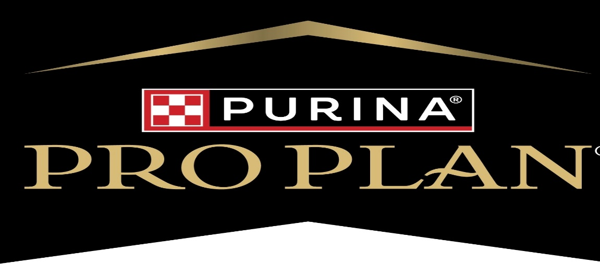

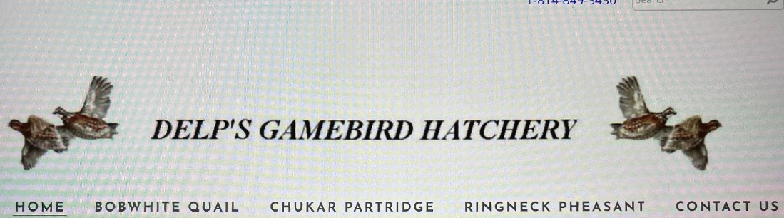

Field Trial Premium List, EVENT #2024289314

German Shorthaired Pointer Club of Ohio
AKC-LICENSED TRIAL

Beaver Valley Pointer Setter Club Grounds
239 Bonzo Road, Rochester, PA
April 6 & 7, 2024

Walking Trial

ALL STAKES OPEN TO ALL AKC REGISTERABLE POINTING BREEDS.
ENTRIES LIMITED TO THE NUMBER OF DOGS THAT CAN BE RUN DURING THE
AVAILABLE DAYLIGHT HOURS AND ENTRIES WILL CLOSE WHEN THE LIMIT IS REACHED IF THAT OCCURS PRIOR TO SPECIFIED CLOSING TIME.
BITCHES IN SEASON MAY NOT COMPETE

This Field Trial is held under the Rules and Regulations of the

AMERICAN KENNEL CLUB

MAIL ENTRIES WITH CHECKS MADE PAYABLE TO GSPCO TO:
Donna McMullen Test Secretary
154 Pleasantview Dr. Monaca, PA 15061
ENTRIES WILL CLOSE AT 7:00 p.m. EDT, Tuesday, March 28, 2024, with the Test Secretary at 154 Pleasantview Dr., Monaca, PA 15061
DRAWING WILL TAKE PLACE AT 7:30 p.m. EDT on Thursday, March 30, 2024, at 154 Pleasantview Dr., Monaca, PA 15061

JUDGES AND STAKES TO BE JUDGED
Paul Gall Open Puppy & Open Gundog
Dennis Meinke Open Puppy & Open Gundog
Rick Johnson Amateur Limited Gundog & Open Limited Gundog
Rex Messner Amateur Limited Gundog & Open Limited Gundog
Victor Wojciak Amateur Gundog & Open Derby
Scott Patrick Amateur Gundog & Open Derby

TEST SCHEDULE AND ENTRY FEES

Open Puppy 7:00 a.m. Local Time Sat. April 6, 2024 $50.00
Amateur Limited Gundog To Follow Open Puppy $60.00
Open Gundog (RET) To Follow Amateur Limited Gundog $60.00
Open Derby To Follow Open Gundog $60.00
Amateur Gundog (RET) To Follow Open Derby $60.00
Open Limited Gundog To Follow Amateur Gundog $60.00

COURSES AND BIRDS
WALKING FIELD TRIAL
ALL STAKES SINGLE COURSE WITHOUT BIRD FIELD
LIBERATED QUAIL AND/OR NATIVE QUAIL/PHEASANT/CHUKAR USED IN ALL STAKES, EXCEPT PUPPY STAKE
A BLANK CARTRIDGE WILL NOT BE FIRED IN PUPPY STAKE
SHOTGUNS WITH BLANK SHELLS ARE NOT PERMITTED IN ANY STAKE.
AMATEUR GUNDOG AND OPEN GUNDOG ARE RETRIEVING STAKES
ONLY AKC-APPROVED TRACKING COLLARS WILL BE PERMITTED AT THIS TRIAL
THIS TRIAL WILL FOLLOW AKC FLEXIBLE FORMAT & GSPCO RESERVES THE RIGHT TO CHANGE COURSES AND ADD OR CHANGE JUDGES/STAKES IF CONDITIONS WARRANT

PRIZES
STANDARD AKC ROSETTES TO ALL PLACED DOGS

OFFICERS
President: Dennis Meinke
Vice President: Chuck Meadors
Secretary: Sher Meinke Treasurer: Gary Nagy

FIELD TRIAL MARSHALS
GSPCO FT Club Members

FIELD TRIAL COMMITTEE
Field Trial Chairman: Chuck Meadors
Field Trial Committee: Sher & Dennis Meinke, Dan Kamp, Peggy Meadors, Don Cummings, Gary Nagy,

OFFICIAL AMERICAN KENNEL CLUB FIELD TRIAL or TEST ENTRY FORM
Club:

German Shorthaired Pointer Club of Ohio
Location:

Beaver Valley Pointer Setter Club Grounds Rochester PA
Date: |  |  |  |  | Event Number: |  |  |  |  |  | Event Type Test or Trial:
April 6&7 2024 |  |  |  |  | 2024289 |  |  |  |  |  | POINTING DOG FIELD TRIAL
Enter in Stake/Test: |  |  |  |  |  |  |  |  |  |  |  |  |  | I enclose entry fees
 |  |  |  |  |  |  |  |  |  |  |  |  |  | in the amount of: $ 60.00
Breed: |  |  |  |  |  |  |  | Reg. #: |  |  |  |  |  |  |  | Sex: | Date of Birth:
 | X | A.K.C. No. |  | A.K.C. Litter No. |  |  |  |  |  | I.L.P. No. |  |  | Foreign No. & list country
Full Name of Dog: |  |  |  |  |  |  |  |  |  |  |  |  |  |  |  |  | Call Name:
Sire:
Dam:
Name of Breeder:
Name of Actual Owner(s):
Owners Address:
City: |  |  |  |  |  |  |  |  |  |  |  |  |  |  | State: |  | Zip:
Name of Owner's Agent/Handler:
A.K.C. Rules, Regulations, Policies and Guidelines are available on the American Kennel Club website: www.akc.orq

AGREEMENT
I (we) agree that the club holding this event has the right to refuse this entry for cause, which the club shall deem sufficient. In consideration of the acceptance of this entry and of the holding of this event and of the opportunity to have the dog judged and to win prizes, ribbons, or trophies, I (we) agree to hold the A.K.C., the event-giving club, their members, directors, governors, officers, agents, superintendents or event secretary and the owner and/or lessor of the premises and any provider of services that are necessary to hold this event and any employees or volunteers of the aforementioned parties, and any A.K.C. approved judge, judging at this event, harmless from any claim for loss or injury which may be alleged to have been caused directly or indirectly to any person or thing by the act of this dog while in or about the event premises or grounds or near any entrance thereto, and I (we) personally assume all responsibility and liability for any such claim; and I (we) further agree to hold the aforementioned parties harmless from any claim for loss, injury or damage to this dog.

Additionally, I (we) hereby assume the sole responsibility for and agree to Indemnify, defend and save the aforementioned parties harmless from any and all loss and expense (including legal fees) by reason of the liability imposed by law upon any of the aforementioned parties for damage because of bodily injuries, including death at any time resulting there from, sustained by any person or persons, including myself (ourselves), or on account of damage to property, arising out of or in consequence of my (our) participation in this event, however such, injuries, death or property damage may be caused, and whether or not the same may have been caused or may be alleged to have been caused by the negligence of the aforementioned parties or any of their employees, agents, or any other persons. I (WE) AGREE THAT ANY CAUSE OF ACTION, CONTROVERSY OR CLAIM ARISING OUT OF OR RELATED TO THE ENTRY, EXHIBITION OR ATTENDANCE AT THE EVENT BETWEEN THE AKC AND MYSELF (OURSELVES) OR AS TO THE CONSTRUCTION, INTERPRETATION AND EFFECT OF THIS AGREEMENT SHALL BE SETTLED BY ARBITRATION PURSUANT TO THE APPLICABLE RULES OF THE AMERICAN ARBITRATION ASSOCIATION. HOWEVER, PRIOR TO ARBITRATION ALL APPLICABLE AKC BYLAWS, RULES, REGULATIONS AND PROCEDURES MUST FIRST BE FOLLOWED AS SET FORTH IN THE AKC CHARTER AND BYLAWS, RULES, REGULATIONS, PUBLISHED POLICIES AND GUIDELINES.
Signature of owner or his agent duly authorized to make this entry
Address of Agent/Handler if different than Owner’s address:
City: |  |  |  |  |  |  |  |  |  |  |  |  |  |  | State: |  | Zip:
Telephone: |  |  |  |  |  | Email Address:

Motel Accommodations*

Quality Inn Clarion Inn Best Western
30 Saint Francis Way 20003 Rt. 19 5001 Cranberry Springs Dr.
Cranberry, PA 16066 Cranberry Twp, PA Cranberry Twp. PA 16066
844-207-6818 724-772-1000 800-568-8520
Behind Bravo Restaurant

* The GSPCO is neither affiliated with nor endorses these establishments. They are listed only as an informational service to those entrants looking for local accommodations.

Directions

Beaver Valley Pointer Setter Club 239 Bonzo Road, Rochester, PA

If you are coming from the East or I-79, go to Cranberry, PA, get on Rt. 19, go to Rochester Road. Take Rochester Road West about 4-3/4 miles to Rt. 989. Rt 989 north just .2 of a mile to Big Knob Road, Big Knob Road 1-3/4 miles to Bonzo Road on the right. Take Bonzo to Club grounds about 3/4 of a mile on left.

If you are coming from the west or I-376, go to Rochester, PA, get on Rt. 68, go east through Rochester. Take Rt .68 about 9 miles to Big Knob Road. Rt. 68 turns to the left here. Big Knob Road is straight ahead. At Big Knob Road, 1.5 miles to Bonzo Road on the left.A Take Bonzo Road to Club grounds about 3/4 of a mile on left.

If you get lost on the way to the test, feel free to contact us but remember cell phone reception may be limited in the test area.

Donna McMullen (F.T. Secretary) 724-622-6142
Chuch Meadors (F.T. Chairman) 330-503-1183

