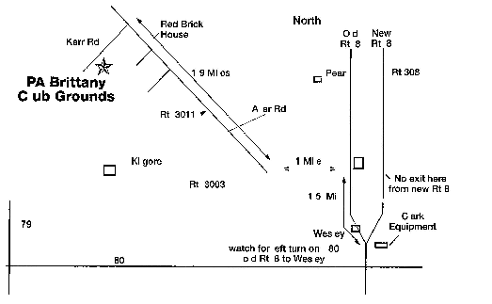
GSP Club of Ohio
Horse Back Trial September 30 – Oct 2, 2016
Pennsylvania Brittany Club Grounds

Field Trial Secretary: Jennifer Sheehan; 330-607-1064, gooje@aol.com
Field Trial Chairmen: Chris Young: 724-422-5825, german_shorthairs2@yahoo.com

Hotels
Comfort Inn 1-80 & Rt. 8, Barkeyville, PA 814-786-7901 (closest to the grounds) Motel 6 1-80 & Rt. 8, Barkeyville, PA 814-786-8375 (closest to the grounds)
NOTE: A 48 hour Cancellation Policy is in effect for all Hotels, or you will be charged. Electrical: Electrical Hook-ups are available for $5.00 a day. Please see Chairman or
Secretary with payment. Campers & Primitive camping will be permitted.

Food: Meals available: Breakfast, Lunch (Limited Menu). Friday and Saturday evening dinner on the grounds. Please notify Chairman or Secretary if you will be attending.

Water: Water available for horses and dogs. Bring drinking water for human consumption.

Please be respectful of the grounds and clean up around your parking area and trailer.

Please unload your horses in the driveway prior to parking as to we do not want to tear up the grounds.

DIRECTIONS:

1-80 to Rt. 8 Barkeyville exit. Go north 1 mile on Rt. 8 to old Rt. 8 turn off. Turn left. Go 1.5 miles to SR 3003, turn left (west) and go 1.0 mile to Rt. 3011. Turn right. Go 1.9 miles to Kerr Rd. (T-intersection, road name is not marked). Turn left. Follow Kerr Rd. to grounds

